DG216 Turbo Module Instruction Manual
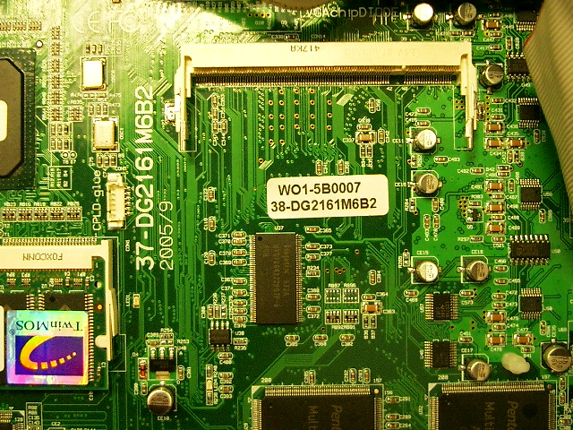
DG216 Main-board

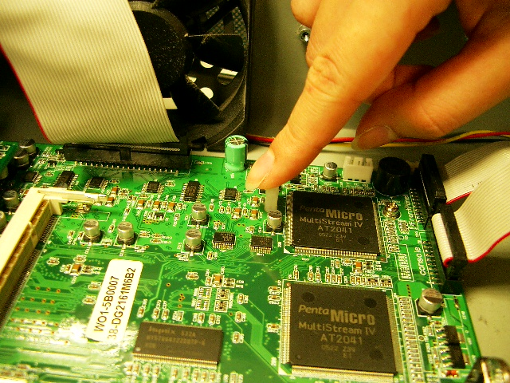
Press the plastic screw into the hole that had reserved on main-board
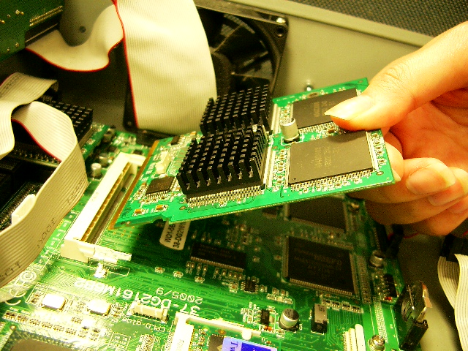
DG216 Turbo module

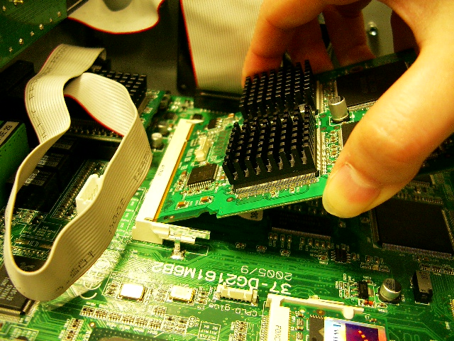
Insert the module into the connector and then press down the module

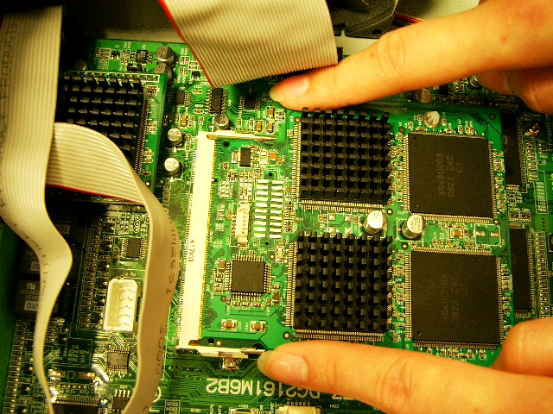
Press 2 sides of the module

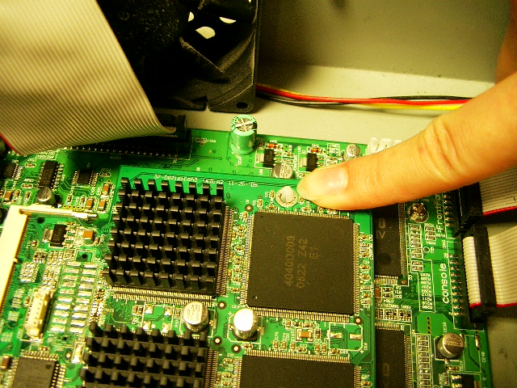
Press the module on the side closed to the plastic screw to fix it

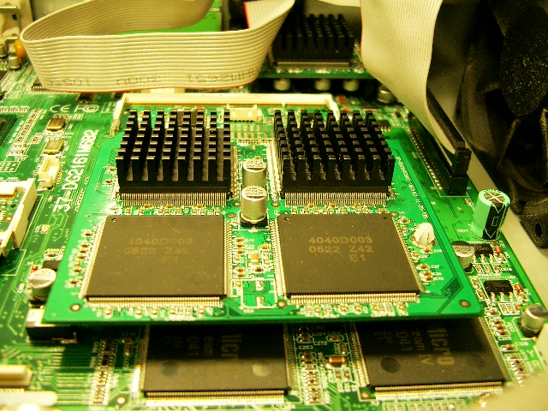
Finished!

