Cable & Connector for SDI CABLING INSTALLATION

High Quality COAX CABLE
Link cable recommend to use high quality “Belden 1694A RG6U” 75Ω Coaxial cable to reach HD resolution at 200M. Use low quality coaxial cable and BNC connectors may case signal loss and effect transmission distance and reliability.
High Quality BNC Connectors
Contact Plating Gold plated pins provide exceptional conductivity.
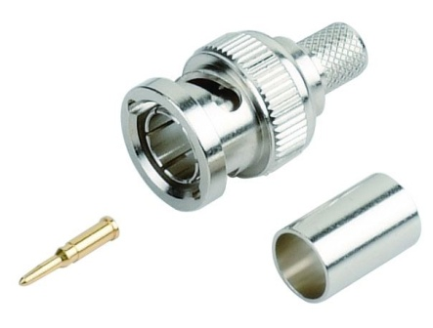
High Quality COAX CABLE INSTALATION
Do not over cut the braid because it will affect the grounding. The image will have lines and noise.
