INDEX
System Requirement 1
Google Play Download Link 1
System Setting 1
Home Screen 2
Scan Devices 2
Add Clients 2
Modify Host 4
Select Client Channel 6
Modify Client 7
Delete Client 8
Add Group 9
Select Group Channel 11
Modify Group 13
Add Client of Group 15
Delete Group 16
Add Scene 17
Apply Scene 19
Modify Scene 21
Delete Scene 22

System Requirement
APP name: Remote Control Center PRO
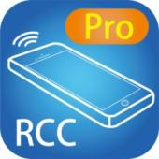
Android version 4 or later
Size: 1.2M

Google Play Download Link
https://play.google.com/store/apps/details?id=sct.com.remotecontrolcenterpro

Google Play Download QR code
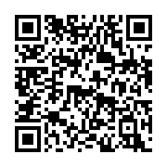

System Setting
Before setting, you have to connect Host / Client / Ethernet Switch / Access Point (Wi-Fi router) together.
Mobile phone connect to the Wi-Fi and set the IP address same with the Host / Client.
System default IP setting is Auto IP, it will assign 169.254.X.X (subnet mask 255.255.0.0) to transmitters and receivers, you could also set to DHCP or Static IP, please refer to user manual web setting chapter: IP Setup.

There are three ways to get the IP address of receiver:
1. Use APP function: Scan Device to get the IP address.
2. Local IP shows on right bottom screen when booting.
3. Press remote control button[MENU] [1] [ENTER](IP Address)

There are two ways to get the IP address of transmitter:
1. Use APP function: Scan Device to get the IP address.
2. Connect a transmitter and receiver and set in the same Channel, press remote control button [MENU] [1] [ENTER] at receiver side (Host IP Address), it will shows the transmitter IP Address on screen(must remove the HDMI cable of transmitter or turn off the video source).

Home Screen
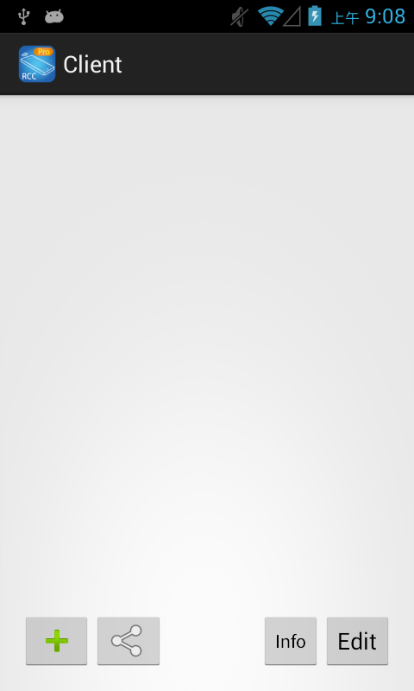
When first time enter the APP will see the Client page

Bottom left「+」to add client
Bottom left (share)icon to enter Group/Scene mode selection page
Bottom right「Info」to enter Information page
Bottom right「Edit」to delete client

Scan Devices
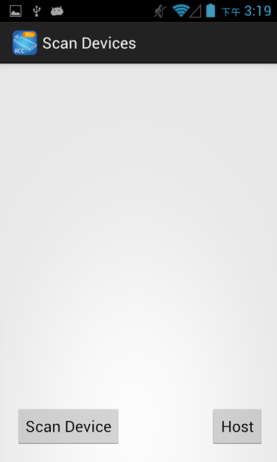
Touch top left「+」to enter Scan Devices page

Touch bottom left「Scan Device」to scan connected clients

Add Clients
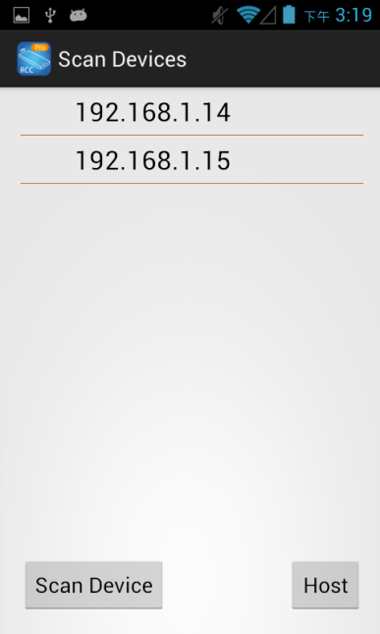
After scan it will show all Clients in the list
Host will be add to bottom right Host page
Touch listed IP address to enter Add Device page to add Client

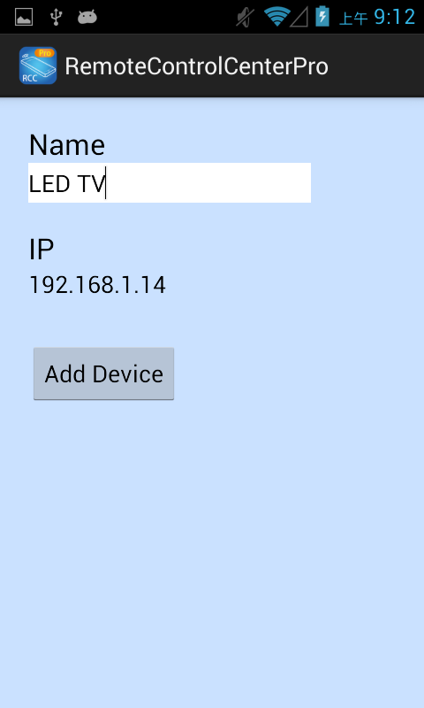

Enter the device Name you prefer and IP address
Notice: Name and IP should be unique, not allow duplicate

Touch「Add Device」button to finish setting.

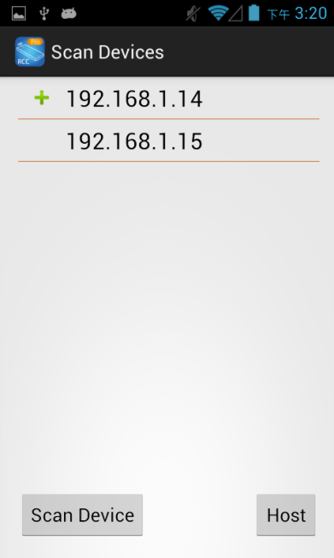

Return to home screen will see the 「+」 sign in front of the added device

Modify Host
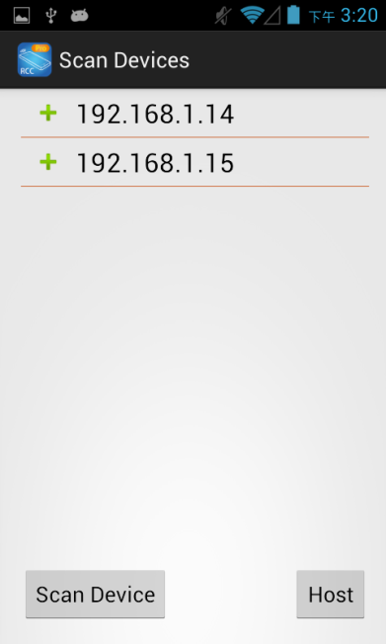

Touch bottom right「Host」to enter Host setting page

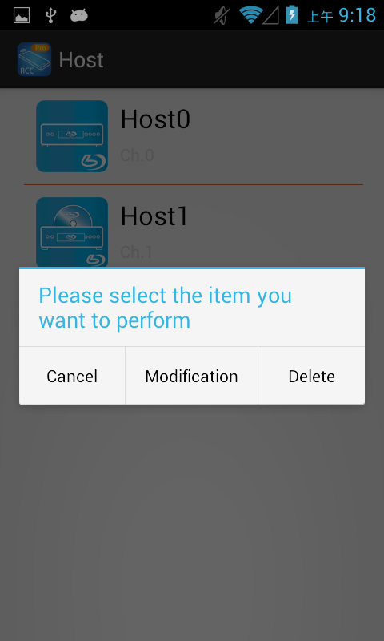

Press Host name to show pop-up dialog, touch「Modification」

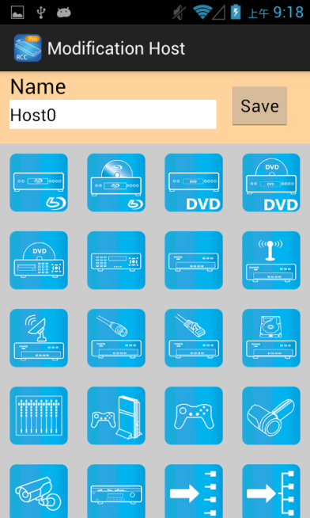

Touch Name column to change name

Touch icon to select different icon

Touch top right「Save」to finish setting

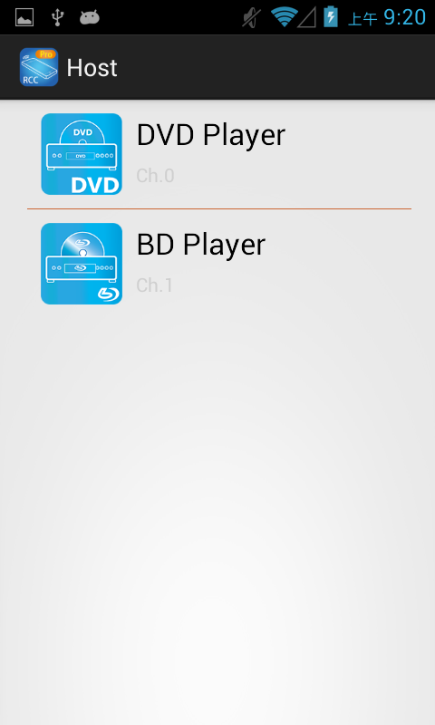
Return to Host page will see the device which just changed

Select Client Channel
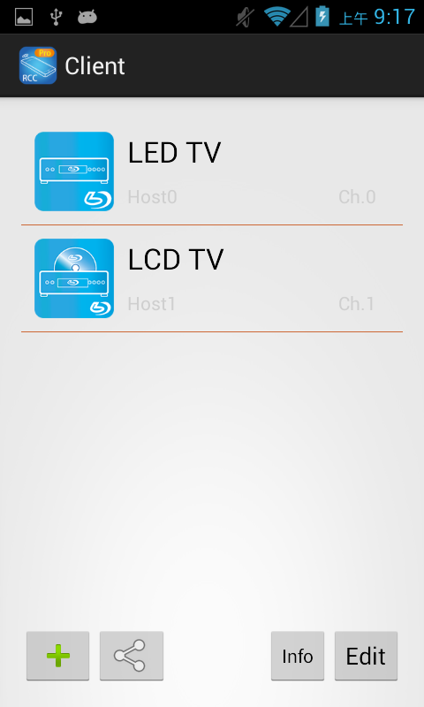
Left icon: Icon for host
Center: Upper big font for client, lower small font for host
Notice: if shows「Specify the host does not exist」means the host not exist
Right Ch.: Number of host channel, e.g.: Channel2 will show「Ch.2」
Right gear: Modify the client name
Touch host name to enter Select Host page

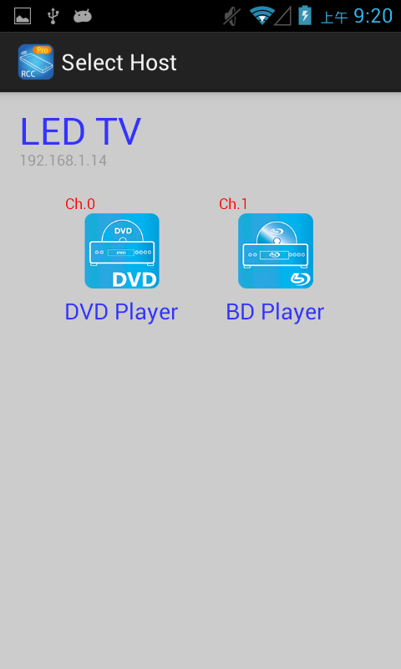

In Select Host page it will list all register hosts for selection

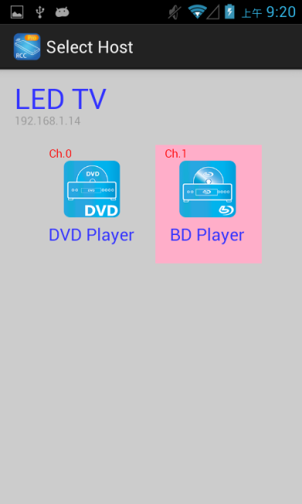

Touch the Host bar to select
The selected channel will be high light and switch the screen immediately

Modify Client
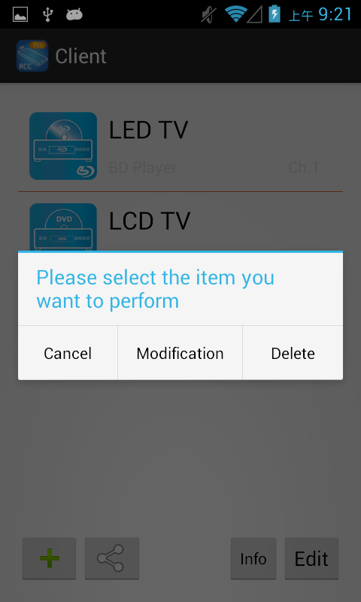

Press client name at to show pop-up dialog, touch 「Modification」

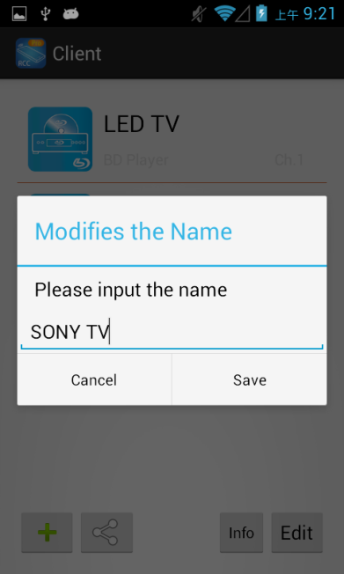

Enter the name in pop-up dialog, touch「Save」to finish

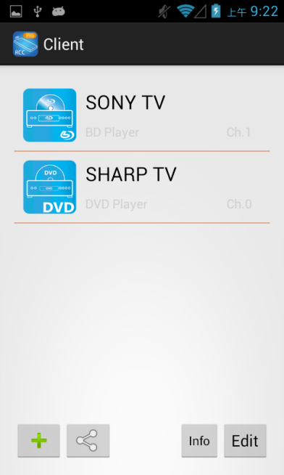

Return to home screen will see the device which just changed

Delete Client

Press Client name to show pop-up dialog

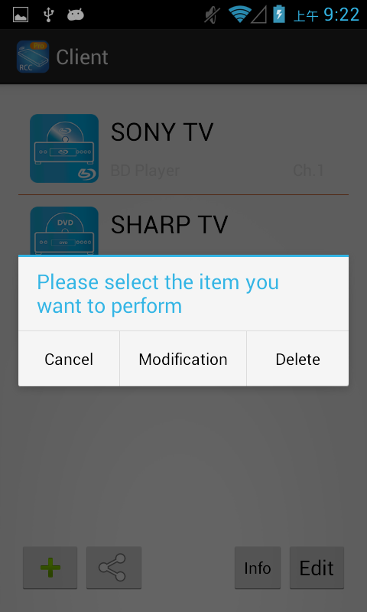

Touch「Delete」to pop-up dialog

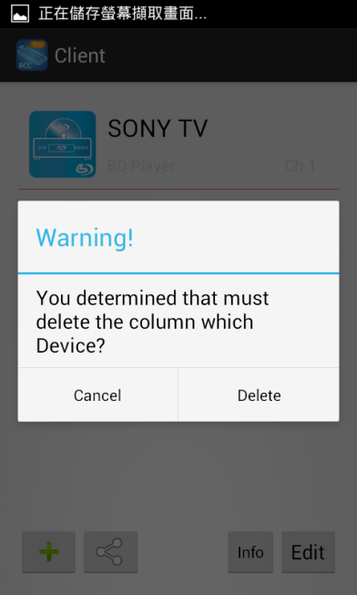

Touch 「Delete」of pop-up dialog to confirm delete

Add Group
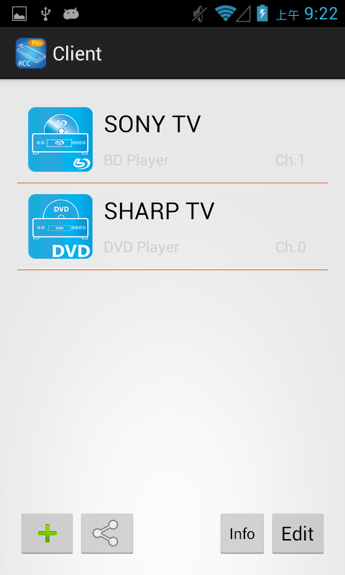
Touch the top right「Edit」at Client page to enable select function

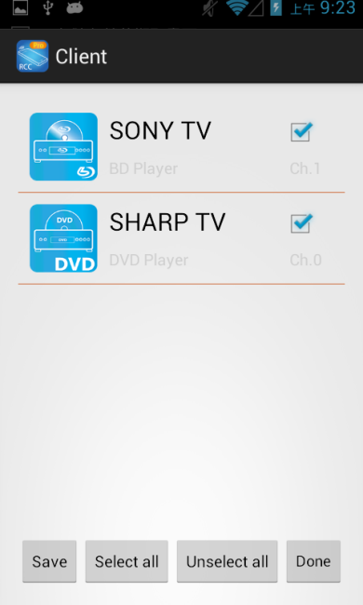

Check the client then touch the bottom left「Save」to show pop-up dialog

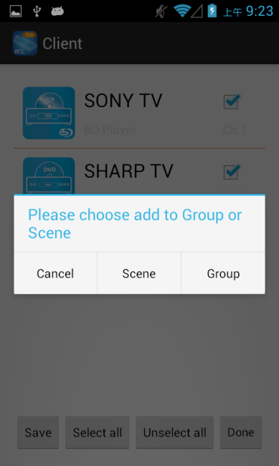

Touch「Group」to pop-up dialog

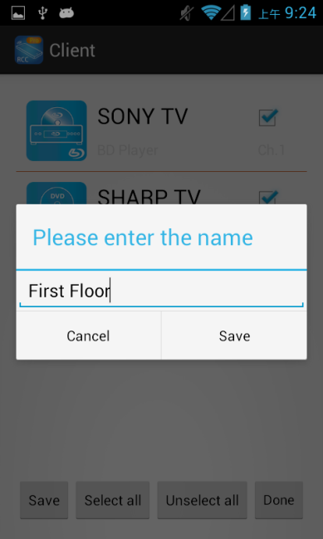

Enter the group name you prefer then touch「Group」to save
Notice: Group name could not be empty or duplicate
Touch top right「Done」to disable select function

Select Group Channel

Touch bottom left(share)icon to enter Group/Scene mode selection page

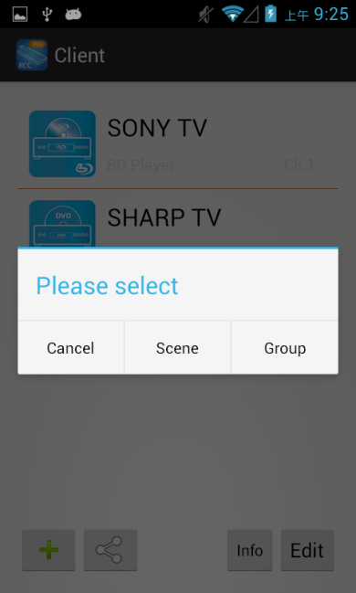

Tough pop-up dialog「Group」to enter group channel selection

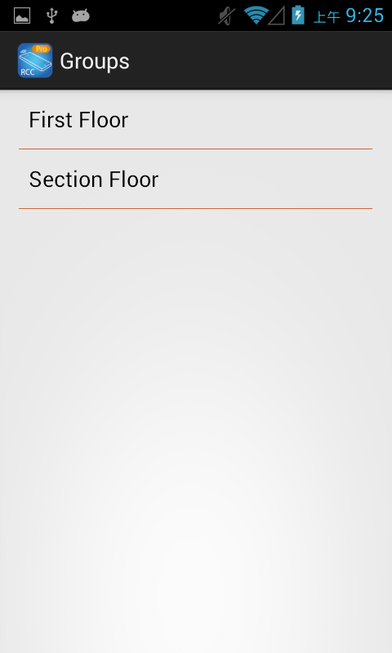

Touch group name enter Select Host page

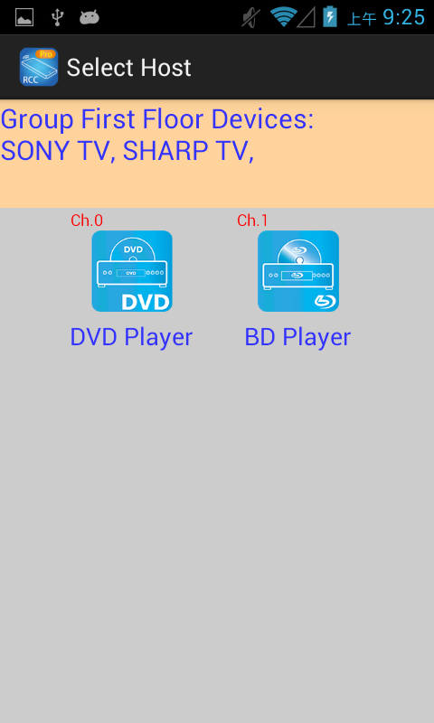

Yellow area shows the devices of group

Gray area shows the available channels

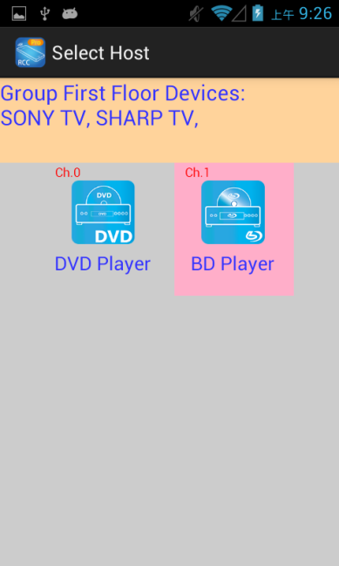

Touch the Host bar to select
The selected channel will be high light and switch the screen immediately

Modify Group
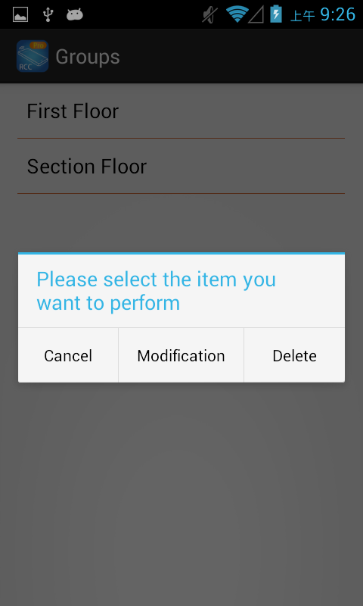

In Group page press group name to show pop-up dialog, touch 「Modification」to enter modify mode

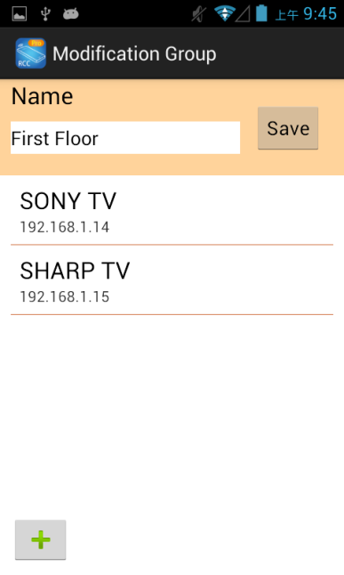

Touch Name column to change group name

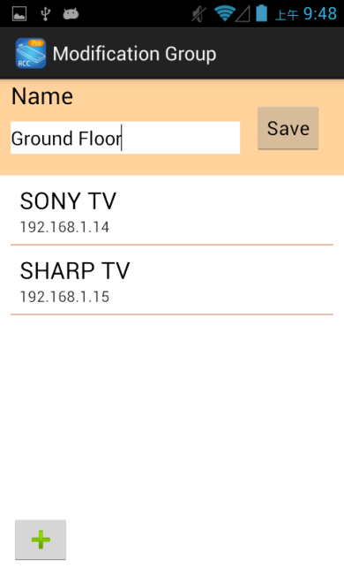

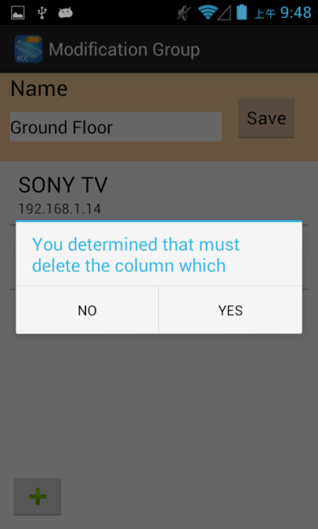

Press the client name to show pop-up dialog, touch「Yes」to show delete dialog

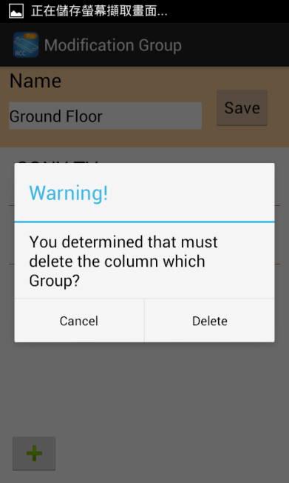

Touch「Delete」to delete the client

Add Client of Group
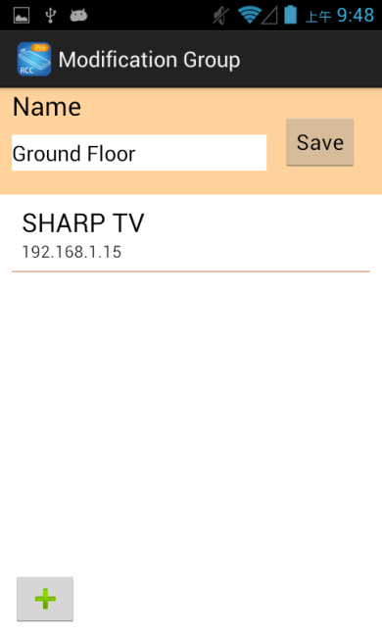

Touch bottom left「+」in Modify Group page to add client

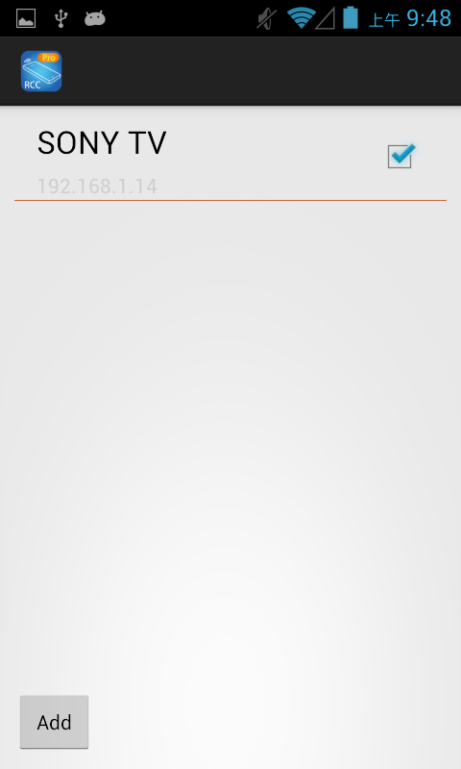

Check the client then touch top right 「Add」, it will return to Modify Group page

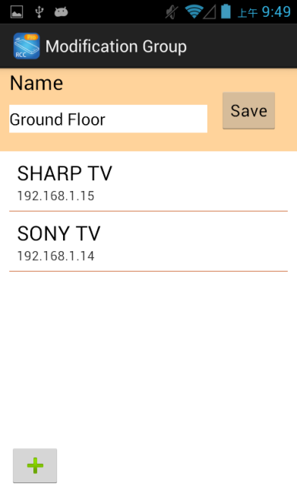

Return to Modify Group page will see the device which just add
Touch「Save」to save the modification

Delete Group
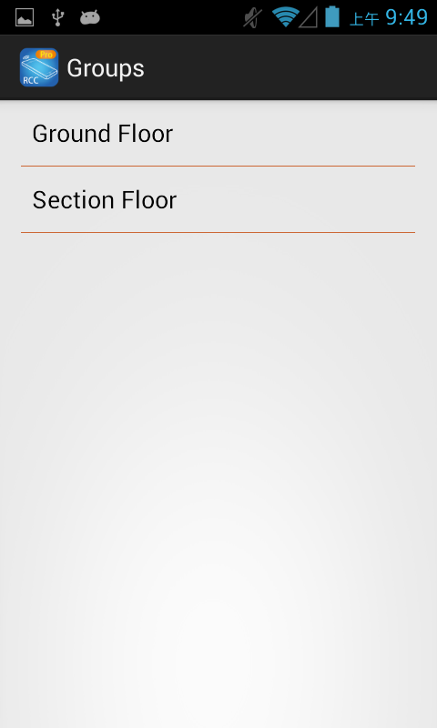

Press group name to show pop- up dialog

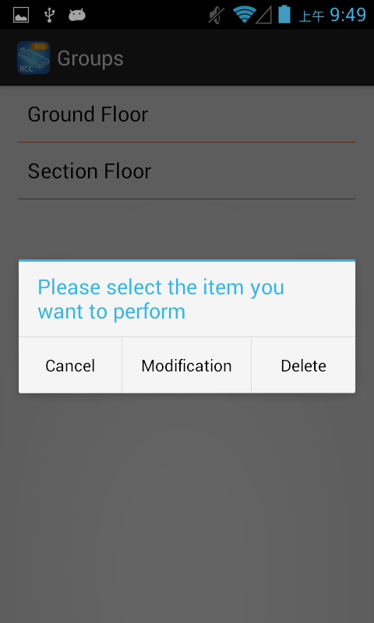

Touch「Delete」

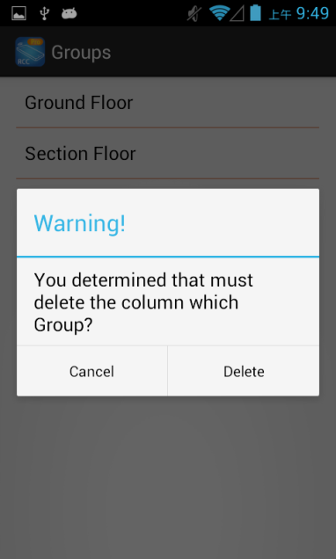

Touch「Delete」button to delete the group
Touch top right 「Done」to exit

Add Scene

Touch the bottom right「Edit」at Client page to enable select function

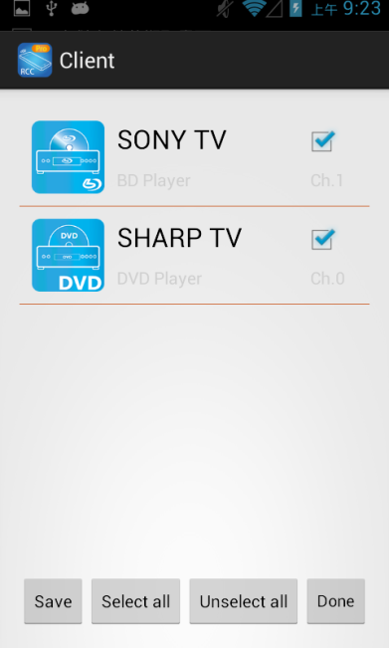

Check the client then touch the bottom center 「Save」
Notice: if shows「Specify the host does not exist」means the host not exist and not able to add the client to Scene

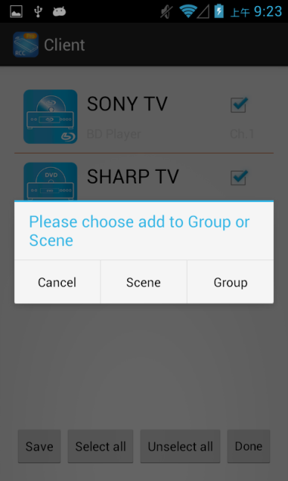

Touch「Scene」to pop-up dialog

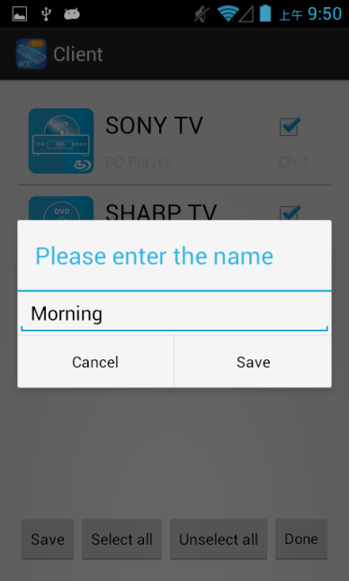

Enter the scene name you prefer then touch「Scene」to save
Notice: Scene name could not be empty or duplicate
Touch top right「Done」to disable select function

Apply Scene

Touch bottom left(share) icon to enter Group/Scene mode selection page

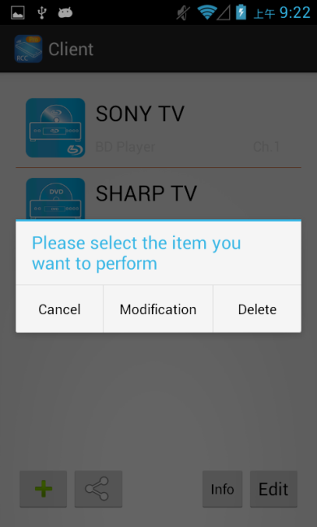

Touch 「Scene」to enter scene mode

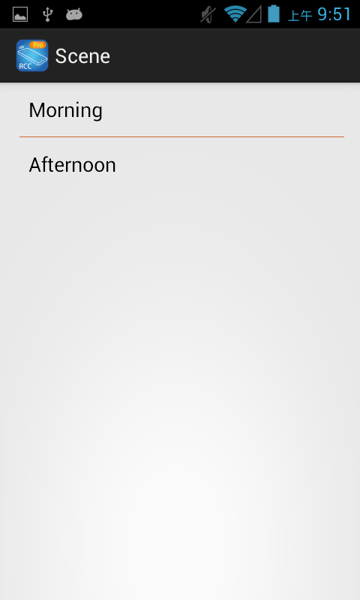

Touch the scene name to apply

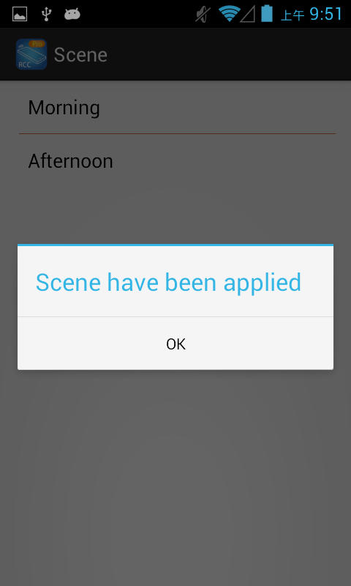

It will pop-up dialog「Scene have been applied」

Modify Scene
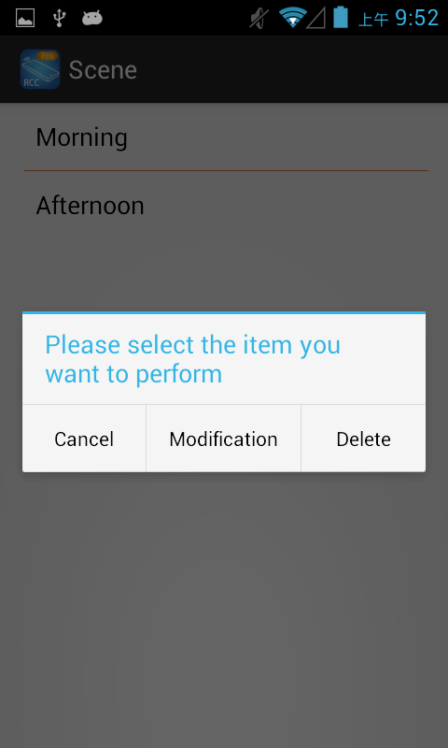

In Scene page press group name to show pop-up dialog, touch 「Modification」to enter modify mode

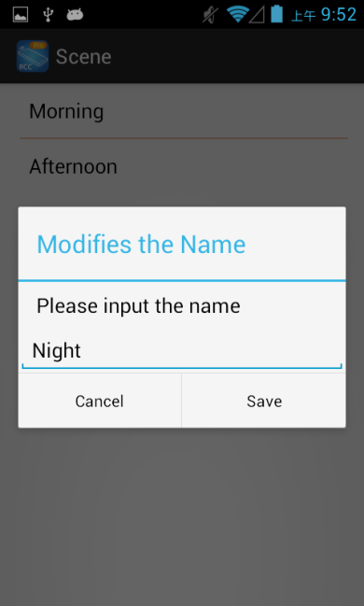

Enter new scene name in pop-up dialog then touch「Save」

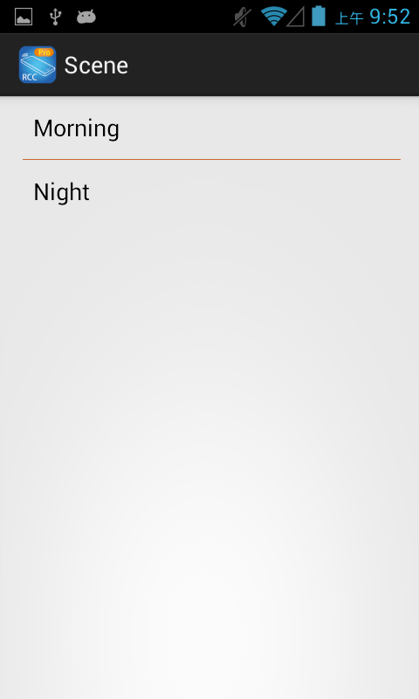

Return to Scene page will see the name which just changed

Delete Scene

In Scene page press group name to show pop-up dialog

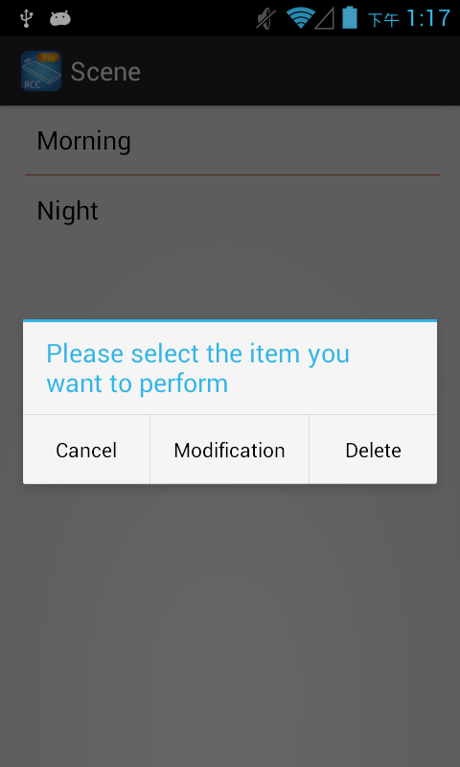

touch 「Delete」to enter modify mode

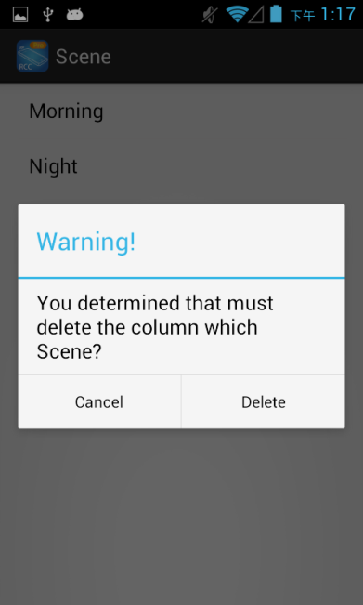

Touch 「Delete」button to delete the scene
Touch top right「Done」to exit

