INDEX
System Requirement 1
iTunes Download Link 1
System Setting 1
Home Screen 2
Add Client 2
Modify Client 3
Modify Host 4
Select Channel of Client 5
Delete Client 6

System Requirement
APP name: Remote Control Center
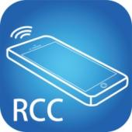
iOS version 7.0 or later
Size: 2.2M

iTunes Download Link
https://itunes.apple.com/us/app/remote-control-center/id929873260?l=zh&ls=1&mt=8

iTunes Download QR code
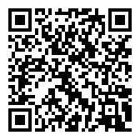

System Setting
Before setting, you have to connect Host / Client / Ethernet Switch / Access Point (Wi-Fi router) together.
Mobile phone connect to the Wi-Fi and set the IP address same with the Host / Client.
System default IP setting is Auto IP, it will assign 169.254.X.X (subnet mask 255.255.0.0) to transmitters and receivers, you could also set to DHCP or Static IP, please refer to user manual web setting chapter: IP Setup.

There are three ways to get the IP address of receiver:
1. Local IP shows on right bottom screen when booting.
2. Press remote control button[MENU] [1] [ENTER](IP Address)

Home Screen
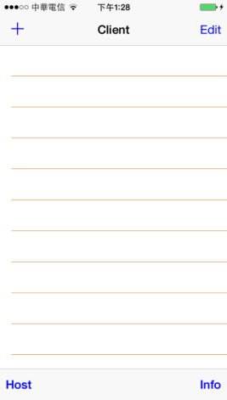
When first time enter the APP will see above home (Client) screen
Top left「+」to add client
Top right「Edit」to delete client

Bottom left「Host」to enter host setting page
Bottom right「Info」to enter Information page

Add Client
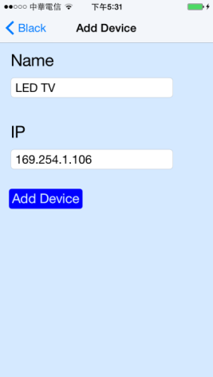

Enter the device Name you prefer and IP address
Notice: Name and IP should be unique, not allow duplicate

Touch「Add Device」button to finish setting.

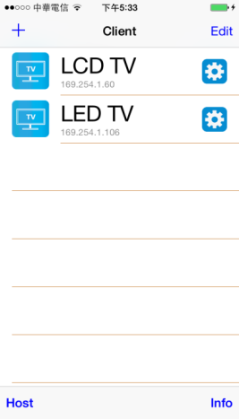

Return to home screen will see the device which just add

Modify Client

Touch the gear icon of client to modify settings

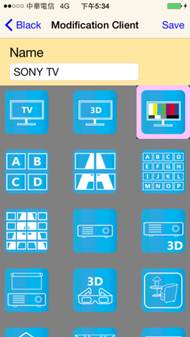

Touch Name column to change name

Touch icon to select different icon

Touch top right「Save」to finish setting
Notice: IP address is not able to modify, please delete the client and add a new one if input wrong IP address

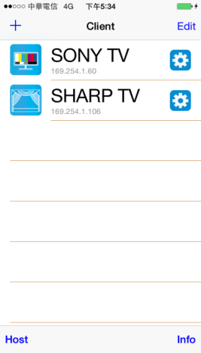
Return to home screen will see the device which just changed

Modify Host
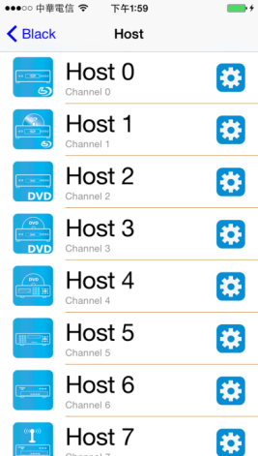
Touch bottom left「Host」to enter host setting page

Touch the gear icon of host to modify settings

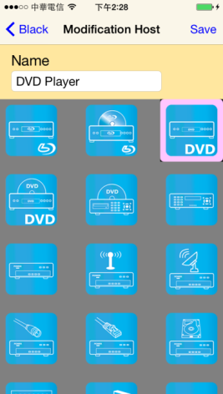

Touch Name column to change name

Touch icon to select different icon

Touch top right「Save」to finish setting

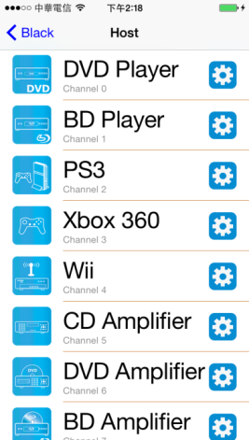
Return to host page will see the device which just changed

Select Channel of Client
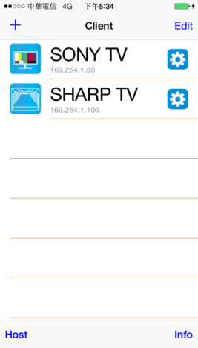

Touch client name to enter channel selection page

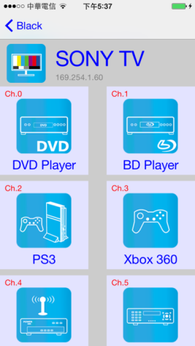

Notice: it will show all 16 channels even does not exist

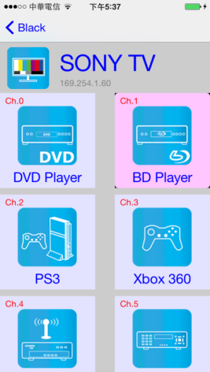

The selected channel will be high light and switch the screen immediately
Notice: it will switch to the channel even does not exist( just like a remote control)

Delete Client
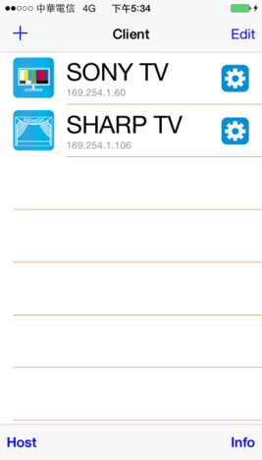
Touch top right 「Edit」to show 「-」icon

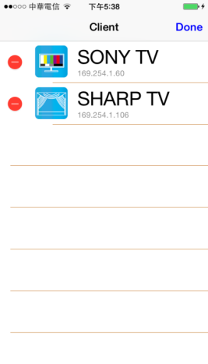

Touch「-」icon to show「Delete」icon

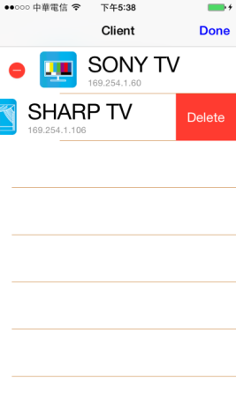

Touch「Delete」icon to delete
Touch top right「Done」to exit

