Configure router with iMac
1999/11/3

Due to iMac computer doesn't support traditional serial port RS-232. Therefore, using console port of Vigor2000 to configure router is impossible. In this chapter you will get the method to setup Vigor2000 via Ethernet LAN connection. In fact, using DHCP protocol to talk between iMac computer and Vigor2000 isdnRouter.

Before you start to configure Vigor2000 via Ethernet port, please make sure the following items:
- Install TCP/IP protocol in your own iMac computer.
- Make sure Vigor2000 has been connect to iMac computer via Ethernet cable.

Now, we step-by-step setup iMac for opening Vigor2000's Web Configurator.

Step 1: Open TCP/IP window on the Mac OS

To click the Apple mark on the left top of desktop of Mac OS, and moving the mouse to select "Control Panels" item. Once the mouse points on "Control Panels" item, another pop-up menu will jump out and then click "TCP/IP" item to open "TCP/IP" window for taking more settings.
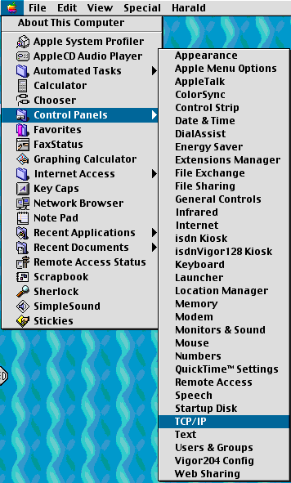
Step 2: Setup TCP/IP settings

On the "TCP/IP" windows, there are three items should be properly configured as following:
Connect via : "Ethernet"
Configure : "Using DHCP Server"
DHCP Client ID : "192.168.1.1"

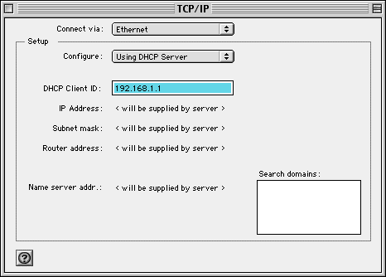

After finishing the settings, click the small square button on the left top of "TCP/IP" window to close the window. You will get the following dialog box, and push the "Save" button to keep the settings.

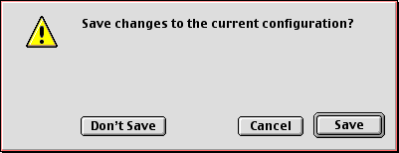

Step 3: Restart iMac

You can click "Special" menu and select "Restart" item to reboot iMac again.
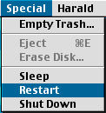

Step 4: Open browser to configure Vigor2000

After rebooting iMac, you could double-click browser icon on the desktop or click "Browse the Internet" in the main menu under "Apple Mark" as following.
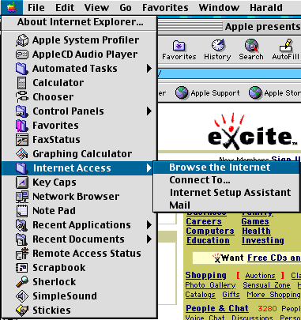

Now, you can type http://192.168.1.1 to open the Web Configurator of Vigor2000.
Here we use default IP address of Vigor2000 for example. Before you opening the Web Configurator, the following dialog box will pop up and ask for "User ID" and "Password". The default values both are "draytek".

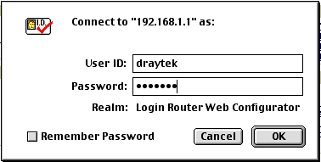

Passing the system authentication, you will get the homepage of Web Configurator as following.

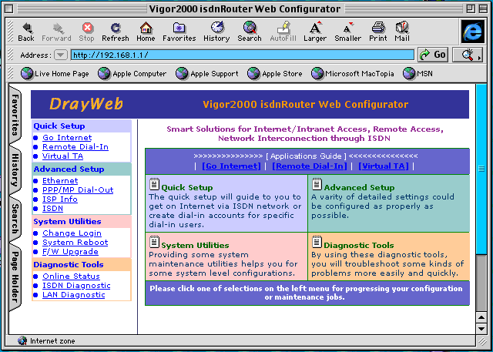

Note: If you can NOT connect to "Vigor2000 isdnRouter Web Configurator", please check iMac's TCP/IP settings whether set correctly or not. In this example, iMac has got an IP address 192.168.1.53 and a subnet mask 255.255.255.0.

